Posted 08/18/2011 at 1:55 pm by JAV

Municipal Building Committee

Agenda
Old Library, Fireplace Room
Tuesday, August 23, 2011
7:30 AM

- Approve minutes

- OPM
  - approval and negotiation process
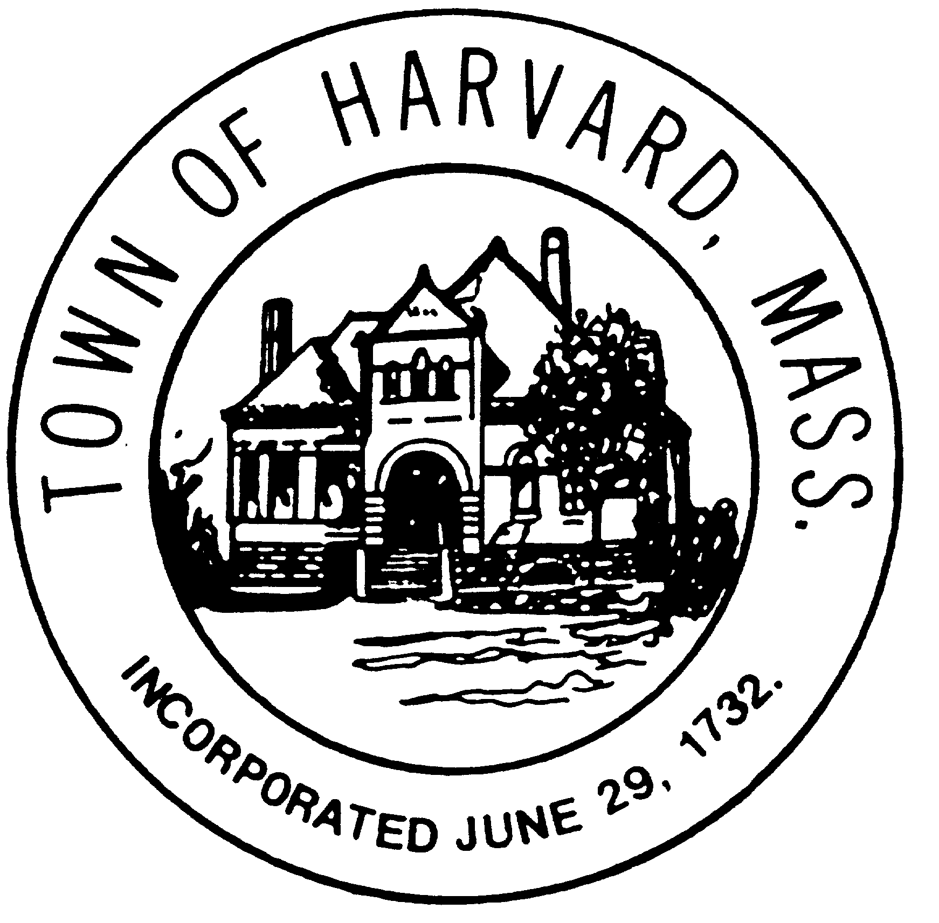
  - letters to other OPM candidates

- CPC project
  - report to BoS on MBC recommendation

- Status of RFS for Architect

- Draft Work Plan
  - Discussion on alternative schedules

- Agenda for next meeting

